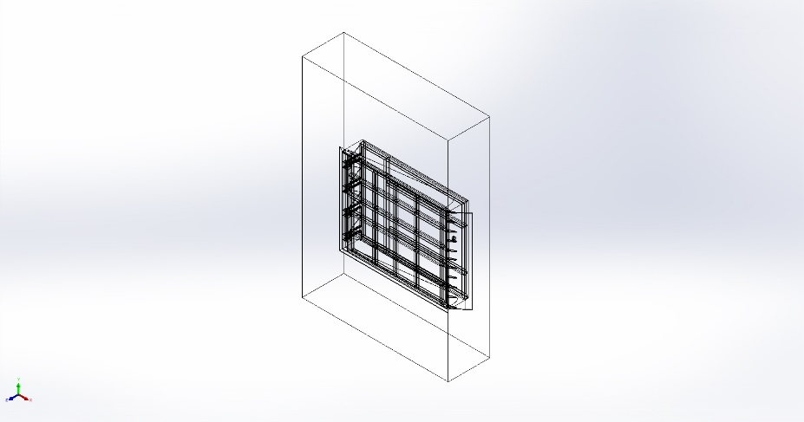
  Simulation of BASE STRACTURE.SLDPRT new
  Date: 19 April 2025
  Designer: Solidworks
  Study name: Static 1
  Analysis type: Static
  Table of Contents
  Description 1
  Assumptions 2
  Model Information 3
  Study Properties 19
  Units 19
  Material Properties 20
  Loads and Fixtures 25
  Connector Definitions 26
  Contact Information 26
  Mesh information 26
  Sensor Details 26
  Resultant Forces 27
  Beams 27
  Study Results 28
  Conclusion 28

Description
No Data

Assumptions

Model Information

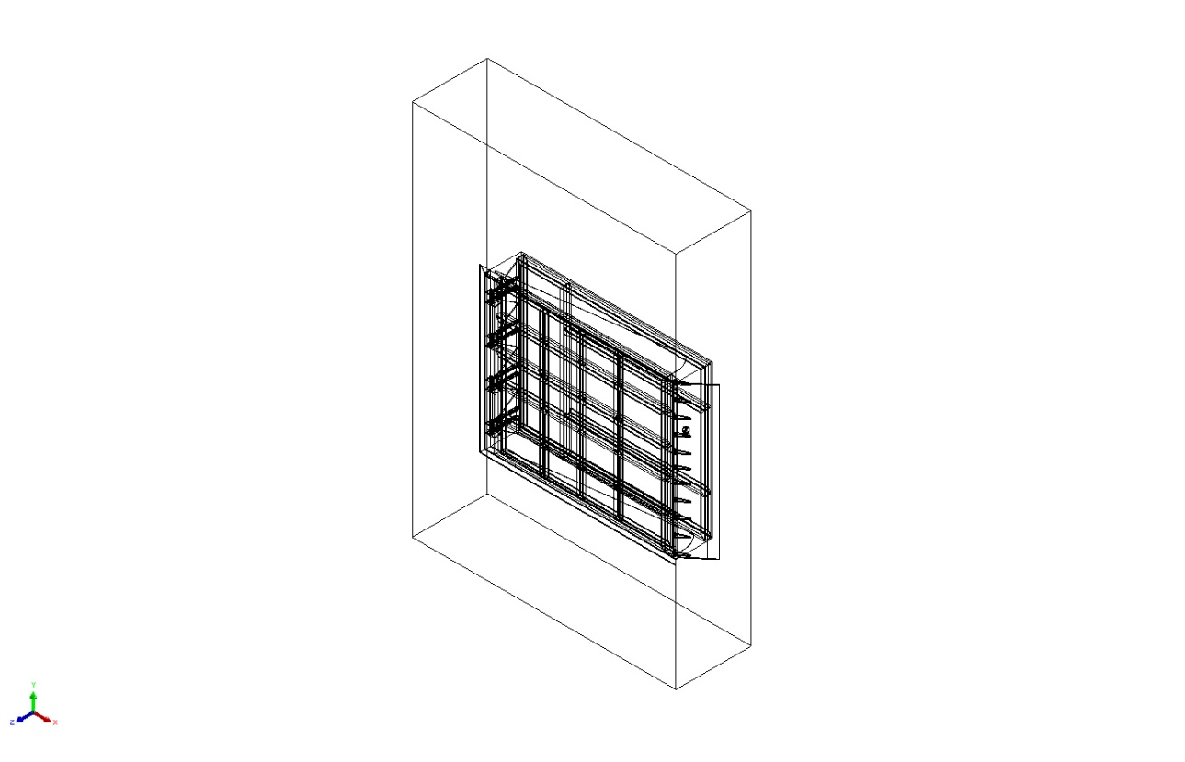
Model name: BASE STRACTURE.SLDPRT new
Current Configuration: Default
Solid Bodies
Document Name and Reference | Treated As | Volumetric Properties | Document Path/Date Modified
Cut-Extrude4[1]  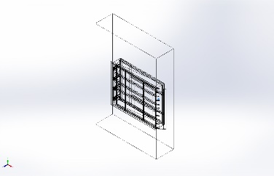 | Solid Body | Mass:0.270797 kg  Volume:3.44087e-05 m^3  Density:7,870 kg/m^3  Weight:2.65381 N | E:\NIHVA AUTOMATION 2024\AUTOMATION\DOCK LEVELER\NEW DEVLOPMENT\1600 mm filp plate-R01.SLDPRT  Apr 17 17:13:01 2025
Cut-Extrude4[2]  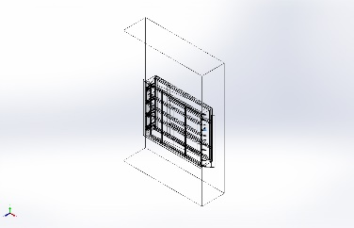 | Solid Body | Mass:0.270797 kg  Volume:3.44087e-05 m^3  Density:7,870 kg/m^3  Weight:2.65381 N | E:\NIHVA AUTOMATION 2024\AUTOMATION\DOCK LEVELER\NEW DEVLOPMENT\1600 mm filp plate-R01.SLDPRT  Apr 17 17:13:01 2025
Boss-Extrude4 | Solid Body | Mass:314.8 kg  Volume:0.04 m^3  Density:7,870 kg/m^3  Weight:3,085.04 N | E:\NIHVA AUTOMATION 2024\AUTOMATION\DOCK LEVELER\NEW DEVLOPMENT\DOCK PLATE-R01.SLDPRT  Apr 19 10:54:25 2025
Boss-Extrude1 | Solid Body | Mass:0.70969 kg  Volume:9.01766e-05 m^3  Density:7,870 kg/m^3  Weight:6.95496 N | E:\NIHVA AUTOMATION 2024\AUTOMATION\DOCK LEVELER\NEW DEVLOPMENT\Dack flip plate bkt new.SLDPRT  Mar 25 16:18:51 2025
Boss-Extrude1 | Solid Body | Mass:0.70969 kg  Volume:9.01766e-05 m^3  Density:7,870 kg/m^3  Weight:6.95496 N | E:\NIHVA AUTOMATION 2024\AUTOMATION\DOCK LEVELER\NEW DEVLOPMENT\Dack flip plate bkt new.SLDPRT  Mar 25 16:18:51 2025
Boss-Extrude1 | Solid Body | Mass:0.70969 kg  Volume:9.01766e-05 m^3  Density:7,870 kg/m^3  Weight:6.95496 N | E:\NIHVA AUTOMATION 2024\AUTOMATION\DOCK LEVELER\NEW DEVLOPMENT\Dack flip plate bkt new.SLDPRT  Mar 25 16:18:51 2025
Boss-Extrude1 | Solid Body | Mass:0.70969 kg  Volume:9.01766e-05 m^3  Density:7,870 kg/m^3  Weight:6.95496 N | E:\NIHVA AUTOMATION 2024\AUTOMATION\DOCK LEVELER\NEW DEVLOPMENT\Dack flip plate bkt new.SLDPRT  Mar 25 16:18:51 2025
Boss-Extrude1 | Solid Body | Mass:0.70969 kg  Volume:9.01766e-05 m^3  Density:7,870 kg/m^3  Weight:6.95496 N | E:\NIHVA AUTOMATION 2024\AUTOMATION\DOCK LEVELER\NEW DEVLOPMENT\Dack flip plate bkt new.SLDPRT  Mar 25 16:18:51 2025
Boss-Extrude1 | Solid Body | Mass:0.70969 kg  Volume:9.01766e-05 m^3  Density:7,870 kg/m^3  Weight:6.95496 N | E:\NIHVA AUTOMATION 2024\AUTOMATION\DOCK LEVELER\NEW DEVLOPMENT\Dack flip plate bkt new.SLDPRT  Mar 25 16:18:51 2025
Cut-Extrude4 | Solid Body | Mass:7.75994 kg  Volume:0.000986016 m^3  Density:7,870 kg/m^3  Weight:76.0475 N | E:\NIHVA AUTOMATION 2024\AUTOMATION\DOCK LEVELER\NEW DEVLOPMENT\MS dia 25 Rod-R011.SLDPRT  Apr 17 16:22:30 2025
Cut-Extrude2  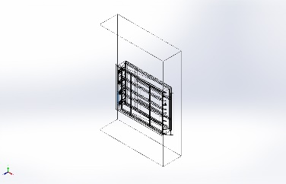 | Solid Body | Mass:2.58606 kg  Volume:0.000328598 m^3  Density:7,870 kg/m^3  Weight:25.3434 N | E:\NIHVA AUTOMATION 2024\AUTOMATION\DOCK LEVELER\NEW DEVLOPMENT\Dack bar new.SLDPRT  Apr 17 10:40:30 2025
Cut-Extrude2  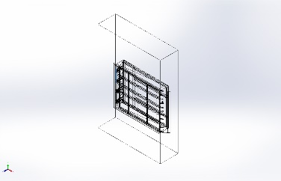 | Solid Body | Mass:2.58606 kg  Volume:0.000328598 m^3  Density:7,870 kg/m^3  Weight:25.3434 N | E:\NIHVA AUTOMATION 2024\AUTOMATION\DOCK LEVELER\NEW DEVLOPMENT\Dack bar new.SLDPRT  Apr 17 10:40:30 2025
Boss-Extrude1  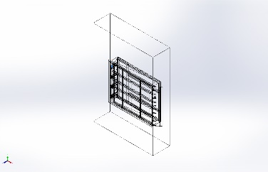 | Solid Body | Mass:0.19675 kg  Volume:2.5e-05 m^3  Density:7,870 kg/m^3  Weight:1.92815 N | E:\NIHVA AUTOMATION 2024\AUTOMATION\DOCK LEVELER\NEW DEVLOPMENT\FOR SUPPORT.SLDPRT  Apr 17 14:57:43 2025
Boss-Extrude1  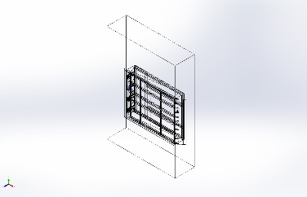 | Solid Body | Mass:0.19675 kg  Volume:2.5e-05 m^3  Density:7,870 kg/m^3  Weight:1.92815 N | E:\NIHVA AUTOMATION 2024\AUTOMATION\DOCK LEVELER\NEW DEVLOPMENT\FOR SUPPORT.SLDPRT  Apr 17 14:57:43 2025
Boss-Extrude1  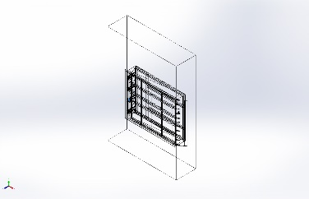 | Solid Body | Mass:0.19675 kg  Volume:2.5e-05 m^3  Density:7,870 kg/m^3  Weight:1.92815 N | E:\NIHVA AUTOMATION 2024\AUTOMATION\DOCK LEVELER\NEW DEVLOPMENT\FOR SUPPORT.SLDPRT  Apr 17 14:57:43 2025
Boss-Extrude1  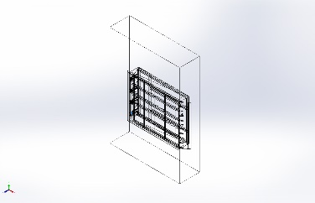 | Solid Body | Mass:0.19675 kg  Volume:2.5e-05 m^3  Density:7,870 kg/m^3  Weight:1.92815 N | E:\NIHVA AUTOMATION 2024\AUTOMATION\DOCK LEVELER\NEW DEVLOPMENT\FOR SUPPORT.SLDPRT  Apr 17 14:57:43 2025
Fillet1  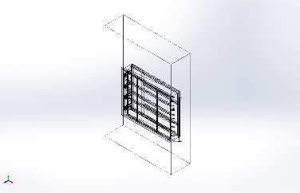 | Solid Body | Mass:0.488644 kg  Volume:6.20894e-05 m^3  Density:7,870 kg/m^3  Weight:4.78871 N | E:\NIHVA AUTOMATION 2024\AUTOMATION\DOCK LEVELER\NEW DEVLOPMENT\Flip Plate MTG BKT R01.SLDPRT  Apr 17 16:51:25 2025
Fillet1  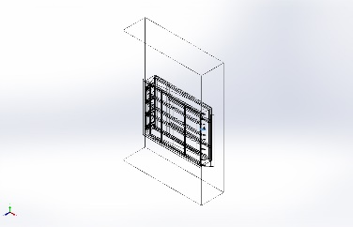 | Solid Body | Mass:0.488644 kg  Volume:6.20894e-05 m^3  Density:7,870 kg/m^3  Weight:4.78871 N | E:\NIHVA AUTOMATION 2024\AUTOMATION\DOCK LEVELER\NEW DEVLOPMENT\Flip Plate MTG BKT R01.SLDPRT  Apr 17 16:51:25 2025
Fillet1  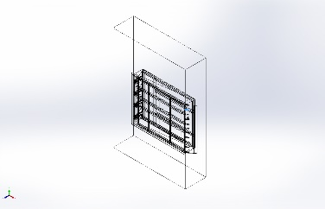 | Solid Body | Mass:0.488644 kg  Volume:6.20894e-05 m^3  Density:7,870 kg/m^3  Weight:4.78871 N | E:\NIHVA AUTOMATION 2024\AUTOMATION\DOCK LEVELER\NEW DEVLOPMENT\Flip Plate MTG BKT R01.SLDPRT  Apr 17 16:51:25 2025
Fillet1  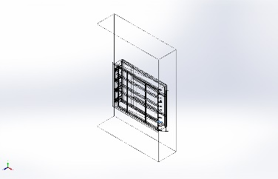 | Solid Body | Mass:0.488644 kg  Volume:6.20894e-05 m^3  Density:7,870 kg/m^3  Weight:4.78871 N | E:\NIHVA AUTOMATION 2024\AUTOMATION\DOCK LEVELER\NEW DEVLOPMENT\Flip Plate MTG BKT R01.SLDPRT  Apr 17 16:51:25 2025
Fillet1  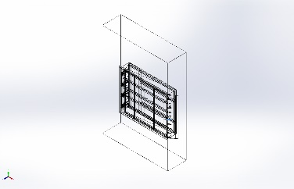 | Solid Body | Mass:0.488644 kg  Volume:6.20894e-05 m^3  Density:7,870 kg/m^3  Weight:4.78871 N | E:\NIHVA AUTOMATION 2024\AUTOMATION\DOCK LEVELER\NEW DEVLOPMENT\Flip Plate MTG BKT R01.SLDPRT  Apr 17 16:51:25 2025
Fillet1  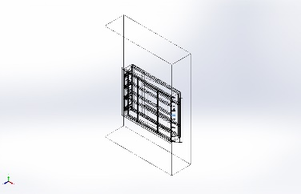 | Solid Body | Mass:0.488644 kg  Volume:6.20894e-05 m^3  Density:7,870 kg/m^3  Weight:4.78871 N | E:\NIHVA AUTOMATION 2024\AUTOMATION\DOCK LEVELER\NEW DEVLOPMENT\Flip Plate MTG BKT R01.SLDPRT  Apr 17 16:51:25 2025
Fillet1  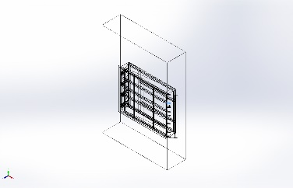 | Solid Body | Mass:0.488644 kg  Volume:6.20894e-05 m^3  Density:7,870 kg/m^3  Weight:4.78871 N | E:\NIHVA AUTOMATION 2024\AUTOMATION\DOCK LEVELER\NEW DEVLOPMENT\Flip Plate MTG BKT R01.SLDPRT  Apr 17 16:51:25 2025
Fillet1  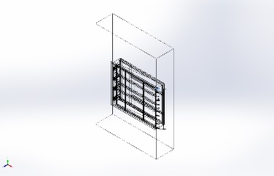 | Solid Body | Mass:0.488644 kg  Volume:6.20894e-05 m^3  Density:7,870 kg/m^3  Weight:4.78871 N | E:\NIHVA AUTOMATION 2024\AUTOMATION\DOCK LEVELER\NEW DEVLOPMENT\Flip Plate MTG BKT R01.SLDPRT  Apr 17 16:51:25 2025
Fillet1  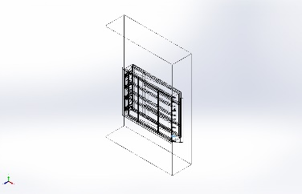 | Solid Body | Mass:0.488644 kg  Volume:6.20894e-05 m^3  Density:7,870 kg/m^3  Weight:4.78871 N | E:\NIHVA AUTOMATION 2024\AUTOMATION\DOCK LEVELER\NEW DEVLOPMENT\Flip Plate MTG BKT R01.SLDPRT  Apr 17 16:51:25 2025
Fillet1  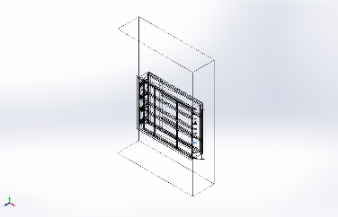 | Solid Body | Mass:0.488644 kg  Volume:6.20894e-05 m^3  Density:7,870 kg/m^3  Weight:4.78871 N | E:\NIHVA AUTOMATION 2024\AUTOMATION\DOCK LEVELER\NEW DEVLOPMENT\Flip Plate MTG BKT R01.SLDPRT  Apr 17 16:51:25 2025
Fillet1  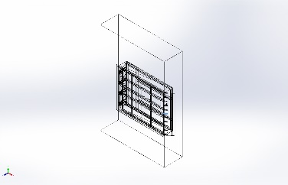 | Solid Body | Mass:0.488644 kg  Volume:6.20894e-05 m^3  Density:7,870 kg/m^3  Weight:4.78871 N | E:\NIHVA AUTOMATION 2024\AUTOMATION\DOCK LEVELER\NEW DEVLOPMENT\Flip Plate MTG BKT R01.SLDPRT  Apr 17 16:51:25 2025
Boss-Extrude1  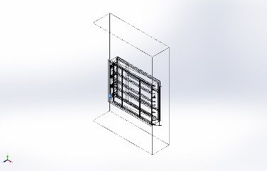 | Solid Body | Mass:4.49308 kg  Volume:0.000570913 m^3  Density:7,870 kg/m^3  Weight:44.0322 N | E:\NIHVA AUTOMATION 2024\AUTOMATION\DOCK LEVELER\NEW DEVLOPMENT\MTG Block new 17-03.SLDPRT  Mar 17 15:57:41 2025
Boss-Extrude1  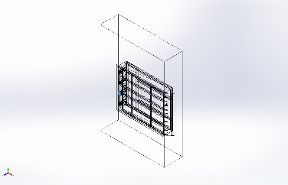 | Solid Body | Mass:4.49308 kg  Volume:0.000570913 m^3  Density:7,870 kg/m^3  Weight:44.0322 N | E:\NIHVA AUTOMATION 2024\AUTOMATION\DOCK LEVELER\NEW DEVLOPMENT\MTG Block new 17-03.SLDPRT  Mar 17 15:57:41 2025
Boss-Extrude1  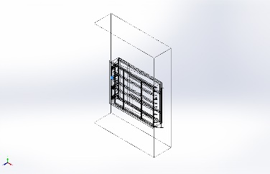 | Solid Body | Mass:4.49308 kg  Volume:0.000570913 m^3  Density:7,870 kg/m^3  Weight:44.0322 N | E:\NIHVA AUTOMATION 2024\AUTOMATION\DOCK LEVELER\NEW DEVLOPMENT\MTG Block new 17-03.SLDPRT  Mar 17 15:57:41 2025
Boss-Extrude1  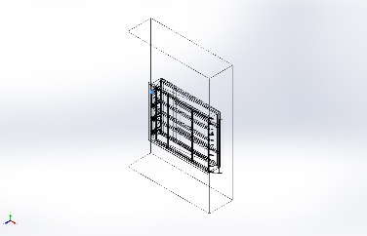 | Solid Body | Mass:4.49308 kg  Volume:0.000570913 m^3  Density:7,870 kg/m^3  Weight:44.0322 N | E:\NIHVA AUTOMATION 2024\AUTOMATION\DOCK LEVELER\NEW DEVLOPMENT\MTG Block new 17-03.SLDPRT  Mar 17 15:57:41 2025
Cut-Extrude1  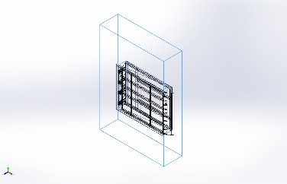 | Solid Body | Mass:118,324 kg  Volume:15.0348 m^3  Density:7,870 kg/m^3  Weight:1.15957e+06 N | E:\NIHVA AUTOMATION 2024\AUTOMATION\DOCK LEVELER\NEW DEVLOPMENT\PIT 3D DWG.SLDPRT  Apr 9 16:01:52 2025
Boss-Extrude1  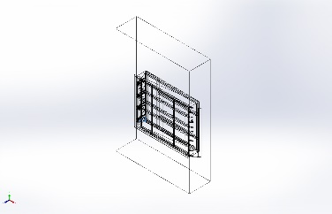 | Solid Body | Mass:2.361 kg  Volume:0.0003 m^3  Density:7,870 kg/m^3  Weight:23.1378 N | E:\NIHVA AUTOMATION 2024\AUTOMATION\DOCK LEVELER\NEW DEVLOPMENT\RIB R01.SLDPRT  Apr 18 17:02:52 2025
Boss-Extrude1  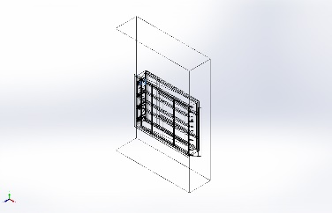 | Solid Body | Mass:2.361 kg  Volume:0.0003 m^3  Density:7,870 kg/m^3  Weight:23.1378 N | E:\NIHVA AUTOMATION 2024\AUTOMATION\DOCK LEVELER\NEW DEVLOPMENT\RIB R01.SLDPRT  Apr 18 17:02:52 2025
Boss-Extrude1  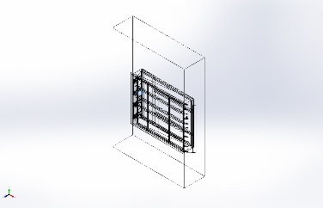 | Solid Body | Mass:2.361 kg  Volume:0.0003 m^3  Density:7,870 kg/m^3  Weight:23.1378 N | E:\NIHVA AUTOMATION 2024\AUTOMATION\DOCK LEVELER\NEW DEVLOPMENT\RIB R01.SLDPRT  Apr 18 17:02:52 2025
Boss-Extrude1  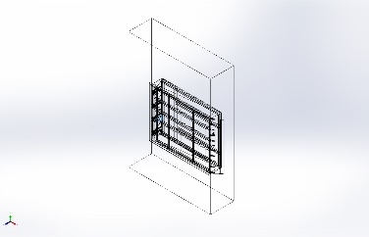 | Solid Body | Mass:2.361 kg  Volume:0.0003 m^3  Density:7,870 kg/m^3  Weight:23.1378 N | E:\NIHVA AUTOMATION 2024\AUTOMATION\DOCK LEVELER\NEW DEVLOPMENT\RIB R01.SLDPRT  Apr 18 17:02:52 2025
Boss-Extrude1  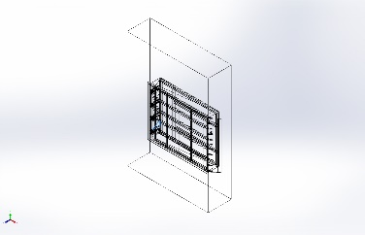 | Solid Body | Mass:2.361 kg  Volume:0.0003 m^3  Density:7,870 kg/m^3  Weight:23.1378 N | E:\NIHVA AUTOMATION 2024\AUTOMATION\DOCK LEVELER\NEW DEVLOPMENT\RIB R01.SLDPRT  Apr 18 17:02:52 2025
Boss-Extrude1  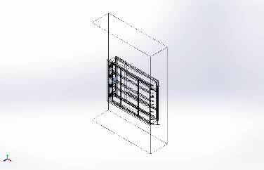 | Solid Body | Mass:2.361 kg  Volume:0.0003 m^3  Density:7,870 kg/m^3  Weight:23.1378 N | E:\NIHVA AUTOMATION 2024\AUTOMATION\DOCK LEVELER\NEW DEVLOPMENT\RIB R01.SLDPRT  Apr 18 17:02:52 2025
Boss-Extrude1  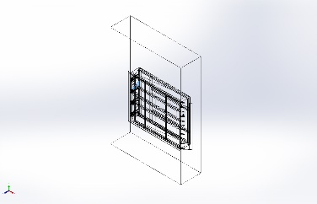 | Solid Body | Mass:2.361 kg  Volume:0.0003 m^3  Density:7,870 kg/m^3  Weight:23.1378 N | E:\NIHVA AUTOMATION 2024\AUTOMATION\DOCK LEVELER\NEW DEVLOPMENT\RIB R01.SLDPRT  Apr 18 17:02:52 2025
Boss-Extrude1  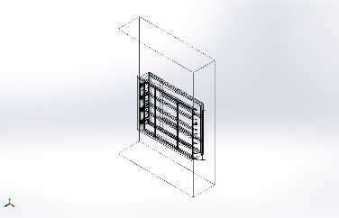 | Solid Body | Mass:2.361 kg  Volume:0.0003 m^3  Density:7,870 kg/m^3  Weight:23.1378 N | E:\NIHVA AUTOMATION 2024\AUTOMATION\DOCK LEVELER\NEW DEVLOPMENT\RIB R01.SLDPRT  Apr 18 17:02:52 2025
Boss-Extrude1  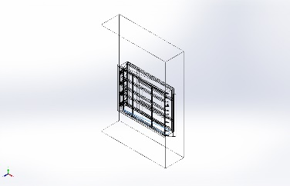 | Solid Body | Mass:6.04206 kg  Volume:0.000767733 m^3  Density:7,870 kg/m^3  Weight:59.2122 N | E:\NIHVA AUTOMATION 2024\AUTOMATION\DOCK LEVELER\NEW DEVLOPMENT\Side Cover R01.SLDPRT  Apr 17 17:52:20 2025
Boss-Extrude1  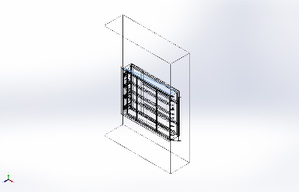 | Solid Body | Mass:6.04206 kg  Volume:0.000767733 m^3  Density:7,870 kg/m^3  Weight:59.2122 N | E:\NIHVA AUTOMATION 2024\AUTOMATION\DOCK LEVELER\NEW DEVLOPMENT\Side Cover R01.SLDPRT  Apr 17 17:52:20 2025
Boss-Extrude1  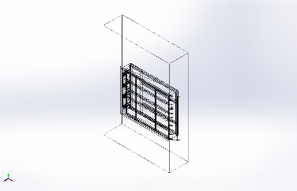 | Solid Body | Mass:0.779436 kg  Volume:9.90389e-05 m^3  Density:7,870 kg/m^3  Weight:7.63847 N | E:\NIHVA AUTOMATION 2024\AUTOMATION\DOCK LEVELER\NEW DEVLOPMENT\dack bkt new-R01.SLDPRT  Apr 17 16:18:23 2025
Boss-Extrude1  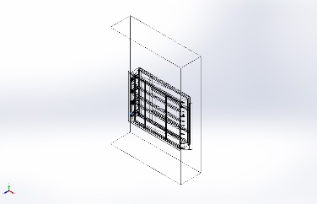 | Solid Body | Mass:0.779436 kg  Volume:9.90389e-05 m^3  Density:7,870 kg/m^3  Weight:7.63847 N | E:\NIHVA AUTOMATION 2024\AUTOMATION\DOCK LEVELER\NEW DEVLOPMENT\dack bkt new-R01.SLDPRT  Apr 17 16:18:23 2025
Boss-Extrude1  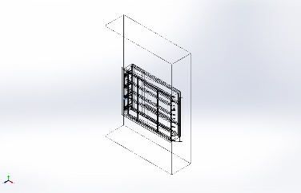 | Solid Body | Mass:0.779436 kg  Volume:9.90389e-05 m^3  Density:7,870 kg/m^3  Weight:7.63847 N | E:\NIHVA AUTOMATION 2024\AUTOMATION\DOCK LEVELER\NEW DEVLOPMENT\dack bkt new-R01.SLDPRT  Apr 17 16:18:23 2025
Boss-Extrude1  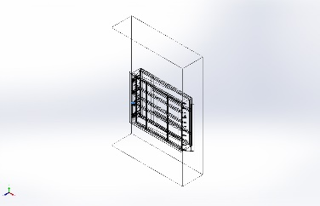 | Solid Body | Mass:0.779436 kg  Volume:9.90389e-05 m^3  Density:7,870 kg/m^3  Weight:7.63847 N | E:\NIHVA AUTOMATION 2024\AUTOMATION\DOCK LEVELER\NEW DEVLOPMENT\dack bkt new-R01.SLDPRT  Apr 17 16:18:23 2025
Boss-Extrude1  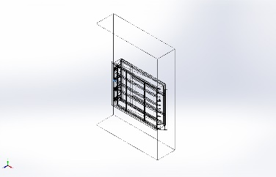 | Solid Body | Mass:0.779436 kg  Volume:9.90389e-05 m^3  Density:7,870 kg/m^3  Weight:7.63847 N | E:\NIHVA AUTOMATION 2024\AUTOMATION\DOCK LEVELER\NEW DEVLOPMENT\dack bkt new-R01.SLDPRT  Apr 17 16:18:23 2025
Boss-Extrude1  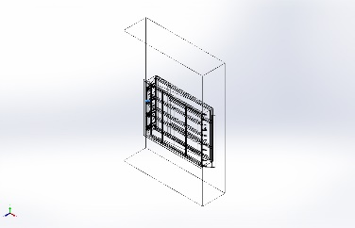 | Solid Body | Mass:0.779436 kg  Volume:9.90389e-05 m^3  Density:7,870 kg/m^3  Weight:7.63847 N | E:\NIHVA AUTOMATION 2024\AUTOMATION\DOCK LEVELER\NEW DEVLOPMENT\dack bkt new-R01.SLDPRT  Apr 17 16:18:23 2025
Boss-Extrude1  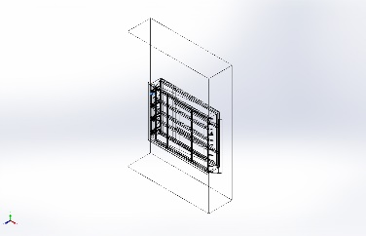 | Solid Body | Mass:0.779436 kg  Volume:9.90389e-05 m^3  Density:7,870 kg/m^3  Weight:7.63847 N | E:\NIHVA AUTOMATION 2024\AUTOMATION\DOCK LEVELER\NEW DEVLOPMENT\dack bkt new-R01.SLDPRT  Apr 17 16:18:23 2025
Boss-Extrude1  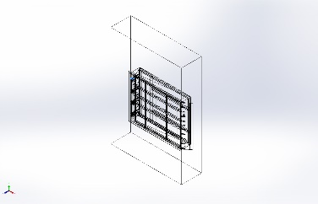 | Solid Body | Mass:0.779436 kg  Volume:9.90389e-05 m^3  Density:7,870 kg/m^3  Weight:7.63847 N | E:\NIHVA AUTOMATION 2024\AUTOMATION\DOCK LEVELER\NEW DEVLOPMENT\dack bkt new-R01.SLDPRT  Apr 17 16:18:23 2025
Beam Bodies:
Document Name and Reference | Formulation | Properties | Document Path/Date Modified
SolidBody 1(Trim/Extend3[2])  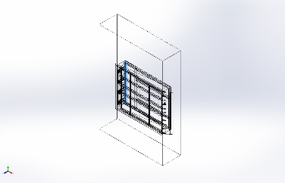 | Beam – Uniform C/S | Section Standard-  Section Area: 0.00131018m^2  Length:1,969.8mm  Volume:0.00258081m^3  Mass Density:7,870kg/m^3  Mass:20.3109kg  Weight:199.047N | E:\NIHVA AUTOMATION 2024\AUTOMATION\DOCK LEVELER\NEW DEVLOPMENT\BASE STRACTURE.SLDPRT  Apr 19 11:33:21 2025
SolidBody 2(Trim/Extend2[2])  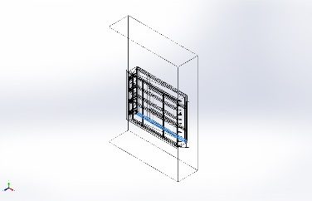 | Beam – Uniform C/S | Section Standard-weldment profiles/iso/c channel  Section Area: 0.00131018m^2  Length:2,469.8mm  Volume:0.0032359m^3  Mass Density:7,870kg/m^3  Mass:25.4665kg  Weight:249.572N | E:\NIHVA AUTOMATION 2024\AUTOMATION\DOCK LEVELER\NEW DEVLOPMENT\BASE STRACTURE.SLDPRT  Apr 19 11:33:21 2025
SolidBody 3(Sb beam - configured 100 X 8(2)[1])  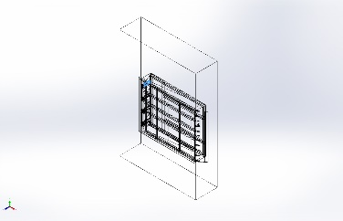 | Beam – Uniform C/S | Section Standard-weldment profiles/iso/sb beam  Section Area: 0.00109003m^2  Length:300mm  Volume:0.000327009m^3  Mass Density:7,870kg/m^3  Mass:2.57356kg  Weight:25.2209N | E:\NIHVA AUTOMATION 2024\AUTOMATION\DOCK LEVELER\NEW DEVLOPMENT\BASE STRACTURE.SLDPRT  Apr 19 11:33:21 2025
SolidBody 4(C channel - configured 100 X 10(4)[3])  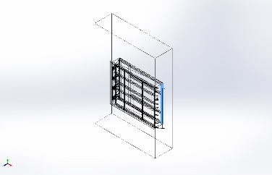 | Beam – Uniform C/S | Section Standard-weldment profiles/iso/c channel  Section Area: 0.00131018m^2  Length:1,969.8mm  Volume:0.00258081m^3  Mass Density:7,870kg/m^3  Mass:20.3109kg  Weight:199.047N | E:\NIHVA AUTOMATION 2024\AUTOMATION\DOCK LEVELER\NEW DEVLOPMENT\BASE STRACTURE.SLDPRT  Apr 19 11:33:21 2025
SolidBody 5(C channel - configured 100 X 10(4)[7])  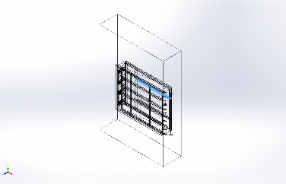 | Beam – Uniform C/S | Section Standard-weldment profiles/iso/c channel  Section Area: 0.00131018m^2  Length:1,841.92mm  Volume:0.00241645m^3  Mass Density:7,870kg/m^3  Mass:19.0174kg  Weight:186.371N | E:\NIHVA AUTOMATION 2024\AUTOMATION\DOCK LEVELER\NEW DEVLOPMENT\BASE STRACTURE.SLDPRT  Apr 19 11:33:21 2025
SolidBody 6(C channel - configured 100 X 10(4)[6])  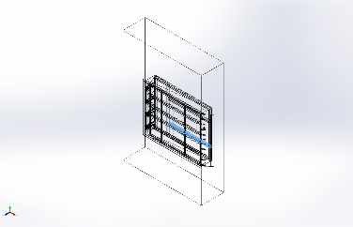 | Beam – Uniform C/S | Section Standard-weldment profiles/iso/c channel  Section Area: 0.00131018m^2  Length:1,841.92mm  Volume:0.00241645m^3  Mass Density:7,870kg/m^3  Mass:19.0174kg  Weight:186.371N | E:\NIHVA AUTOMATION 2024\AUTOMATION\DOCK LEVELER\NEW DEVLOPMENT\BASE STRACTURE.SLDPRT  Apr 19 11:33:21 2025
SolidBody 7(Sb beam - configured 100 X 8(2)[2])  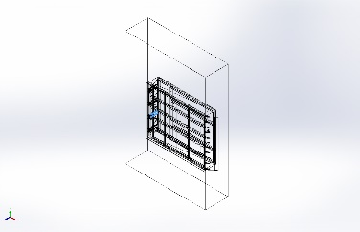 | Beam – Uniform C/S | Section Standard-weldment profiles/iso/sb beam  Section Area: 0.00109003m^2  Length:300mm  Volume:0.000327009m^3  Mass Density:7,870kg/m^3  Mass:2.57356kg  Weight:25.2209N | E:\NIHVA AUTOMATION 2024\AUTOMATION\DOCK LEVELER\NEW DEVLOPMENT\BASE STRACTURE.SLDPRT  Apr 19 11:33:21 2025
SolidBody 8(Sb beam - configured 100 X 8(2)[4])  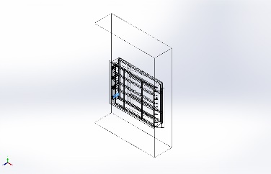 | Beam – Uniform C/S | Section Standard-weldment profiles/iso/sb beam  Section Area: 0.00109003m^2  Length:300mm  Volume:0.000327009m^3  Mass Density:7,870kg/m^3  Mass:2.57356kg  Weight:25.2209N | E:\NIHVA AUTOMATION 2024\AUTOMATION\DOCK LEVELER\NEW DEVLOPMENT\BASE STRACTURE.SLDPRT  Apr 19 11:33:21 2025
SolidBody 9(Trim/Extend3[1])  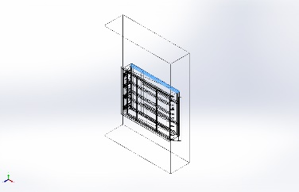 | Beam – Uniform C/S | Section Standard-weldment profiles/iso/c channel  Section Area: 0.00131018m^2  Length:2,469.8mm  Volume:0.0032359m^3  Mass Density:7,870kg/m^3  Mass:25.4665kg  Weight:249.572N | E:\NIHVA AUTOMATION 2024\AUTOMATION\DOCK LEVELER\NEW DEVLOPMENT\BASE STRACTURE.SLDPRT  Apr 19 11:33:21 2025
SolidBody 10(Trim/Extend1[2])  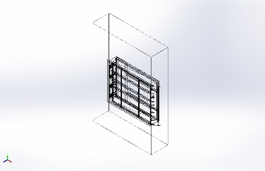 | Beam – Uniform C/S | Section Standard-  Section Area: 1.7405e-05m^2  Length:100mm  Volume:1.7405e-06m^3  Mass Density:7,870kg/m^3  Mass:0.0136977kg  Weight:0.134238N | E:\NIHVA AUTOMATION 2024\AUTOMATION\DOCK LEVELER\NEW DEVLOPMENT\BASE STRACTURE.SLDPRT  Apr 19 11:33:21 2025
SolidBody 11(Sb beam - configured 100 X 8(2)[3])  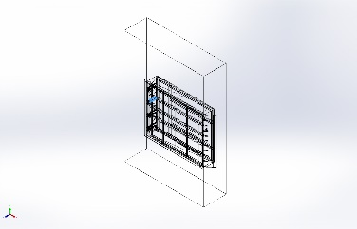 | Beam – Uniform C/S | Section Standard-weldment profiles/iso/sb beam  Section Area: 0.00109003m^2  Length:300mm  Volume:0.000327009m^3  Mass Density:7,870kg/m^3  Mass:2.57356kg  Weight:25.2209N | E:\NIHVA AUTOMATION 2024\AUTOMATION\DOCK LEVELER\NEW DEVLOPMENT\BASE STRACTURE.SLDPRT  Apr 19 11:33:21 2025
SolidBody 12(C channel - configured 100 X 10(4)[5])  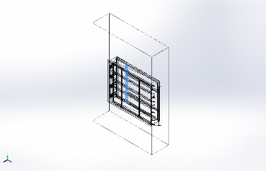 | Beam – Uniform C/S | Section Standard-weldment profiles/iso/c channel  Section Area: 0.00131018m^2  Length:1,954.18mm  Volume:0.00256355m^3  Mass Density:7,870kg/m^3  Mass:20.1751kg  Weight:197.716N | E:\NIHVA AUTOMATION 2024\AUTOMATION\DOCK LEVELER\NEW DEVLOPMENT\BASE STRACTURE.SLDPRT  Apr 19 11:33:21 2025
SolidBody 1(Trim/Extend15[15])  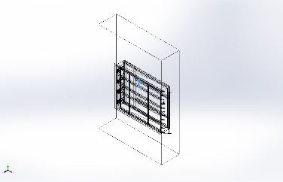 | Beam – Uniform C/S | Section Standard-weldment profiles/iso/rectangular tube  Section Area: 0.000720823m^2  Length:349.83mm  Volume:0.000252166m^3  Mass Density:7,870kg/m^3  Mass:1.98454kg  Weight:19.4485N | E:\NIHVA AUTOMATION 2024\AUTOMATION\DOCK LEVELER\NEW DEVLOPMENT\DOCK PLATE-R01.SLDPRT  Apr 19 10:54:25 2025
SolidBody 2(Trim/Extend15[3])  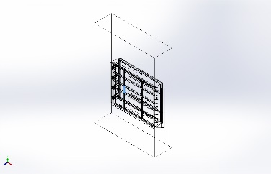 | Beam – Uniform C/S | Section Standard-weldment profiles/iso/rectangular tube  Section Area: 0.000720823m^2  Length:352.496mm  Volume:0.000256722m^3  Mass Density:7,870kg/m^3  Mass:2.02041kg  Weight:19.8N | E:\NIHVA AUTOMATION 2024\AUTOMATION\DOCK LEVELER\NEW DEVLOPMENT\DOCK PLATE-R01.SLDPRT  Apr 19 10:54:25 2025
SolidBody 3(Trim/Extend14[1])  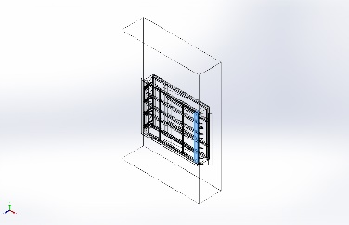 | Beam – Uniform C/S | Section Standard-weldment profiles/iso/c channel  Section Area: 0.00131018m^2  Length:1,969.8mm  Volume:0.00258081m^3  Mass Density:7,870kg/m^3  Mass:20.3109kg  Weight:199.047N | E:\NIHVA AUTOMATION 2024\AUTOMATION\DOCK LEVELER\NEW DEVLOPMENT\DOCK PLATE-R01.SLDPRT  Apr 19 10:54:25 2025
SolidBody 4(Trim/Extend15[14])  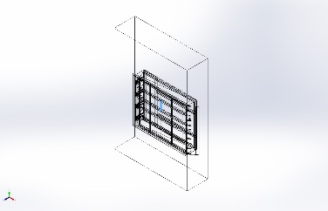 | Beam – Uniform C/S | Section Standard-weldment profiles/iso/rectangular tube  Section Area: 0.000720823m^2  Length:376.248mm  Volume:0.000272526m^3  Mass Density:7,870kg/m^3  Mass:2.14478kg  Weight:21.0188N | E:\NIHVA AUTOMATION 2024\AUTOMATION\DOCK LEVELER\NEW DEVLOPMENT\DOCK PLATE-R01.SLDPRT  Apr 19 10:54:25 2025
SolidBody 5(Trim/Extend15[1])  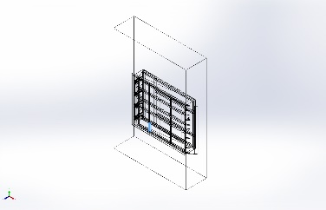 | Beam – Uniform C/S | Section Standard-weldment profiles/iso/rectangular tube  Section Area: 0.000720823m^2  Length:352.922mm  Volume:0.000254394m^3  Mass Density:7,870kg/m^3  Mass:2.00208kg  Weight:19.6204N | E:\NIHVA AUTOMATION 2024\AUTOMATION\DOCK LEVELER\NEW DEVLOPMENT\DOCK PLATE-R01.SLDPRT  Apr 19 10:54:25 2025
SolidBody 6(Trim/Extend12[2])  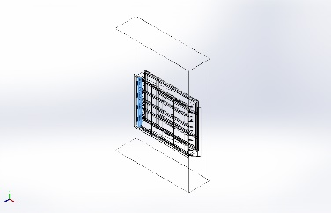 | Beam – Uniform C/S | Section Standard-  Section Area: 0.00131018m^2  Length:1,969.8mm  Volume:0.00258081m^3  Mass Density:7,870kg/m^3  Mass:20.3109kg  Weight:199.047N | E:\NIHVA AUTOMATION 2024\AUTOMATION\DOCK LEVELER\NEW DEVLOPMENT\DOCK PLATE-R01.SLDPRT  Apr 19 10:54:25 2025
SolidBody 7(Trim/Extend15[7])  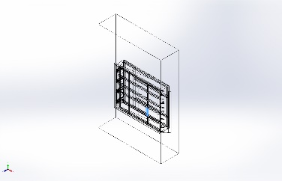 | Beam – Uniform C/S | Section Standard-weldment profiles/iso/rectangular tube  Section Area: 0.000720823m^2  Length:376.248mm  Volume:0.000272526m^3  Mass Density:7,870kg/m^3  Mass:2.14478kg  Weight:21.0188N | E:\NIHVA AUTOMATION 2024\AUTOMATION\DOCK LEVELER\NEW DEVLOPMENT\DOCK PLATE-R01.SLDPRT  Apr 19 10:54:25 2025
SolidBody 8(Trim/Extend10[3])  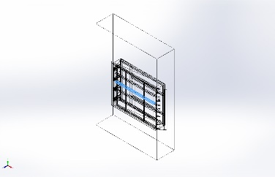 | Beam – Uniform C/S | Section Standard-weldment profiles/iso/c channel  Section Area: 0.00131018m^2  Length:2,183.83mm  Volume:0.00286764m^3  Mass Density:7,870kg/m^3  Mass:22.5683kg  Weight:221.169N | E:\NIHVA AUTOMATION 2024\AUTOMATION\DOCK LEVELER\NEW DEVLOPMENT\DOCK PLATE-R01.SLDPRT  Apr 19 10:54:25 2025
SolidBody 9(Trim/Extend15[13])  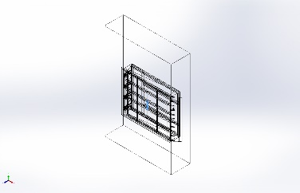 | Beam – Uniform C/S | Section Standard-weldment profiles/iso/rectangular tube  Section Area: 0.000720823m^2  Length:352.496mm  Volume:0.000256722m^3  Mass Density:7,870kg/m^3  Mass:2.02041kg  Weight:19.8N | E:\NIHVA AUTOMATION 2024\AUTOMATION\DOCK LEVELER\NEW DEVLOPMENT\DOCK PLATE-R01.SLDPRT  Apr 19 10:54:25 2025
SolidBody 10(Trim/Extend10[1])  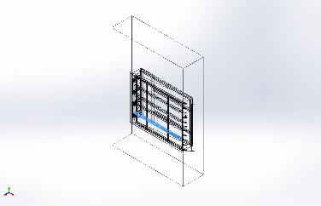 | Beam – Uniform C/S | Section Standard-weldment profiles/iso/c channel  Section Area: 0.00131018m^2  Length:2,183.83mm  Volume:0.00286764m^3  Mass Density:7,870kg/m^3  Mass:22.5683kg  Weight:221.169N | E:\NIHVA AUTOMATION 2024\AUTOMATION\DOCK LEVELER\NEW DEVLOPMENT\DOCK PLATE-R01.SLDPRT  Apr 19 10:54:25 2025
SolidBody 11(Trim/Extend15[10])  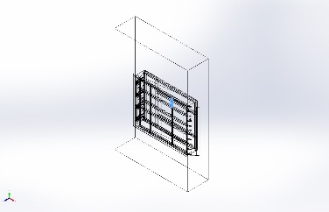 | Beam – Uniform C/S | Section Standard-weldment profiles/iso/rectangular tube  Section Area: 0.000720823m^2  Length:356.709mm  Volume:0.000257124m^3  Mass Density:7,870kg/m^3  Mass:2.02356kg  Weight:19.8309N | E:\NIHVA AUTOMATION 2024\AUTOMATION\DOCK LEVELER\NEW DEVLOPMENT\DOCK PLATE-R01.SLDPRT  Apr 19 10:54:25 2025
SolidBody 12(Trim/Extend15[9])  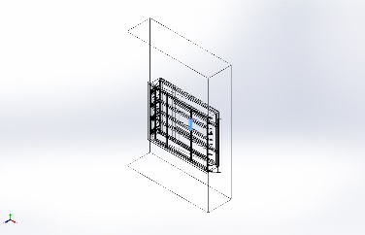 | Beam – Uniform C/S | Section Standard-weldment profiles/iso/rectangular tube  Section Area: 0.000720823m^2  Length:376.248mm  Volume:0.000272526m^3  Mass Density:7,870kg/m^3  Mass:2.14478kg  Weight:21.0188N | E:\NIHVA AUTOMATION 2024\AUTOMATION\DOCK LEVELER\NEW DEVLOPMENT\DOCK PLATE-R01.SLDPRT  Apr 19 10:54:25 2025
SolidBody 13(Trim/Extend14[2])  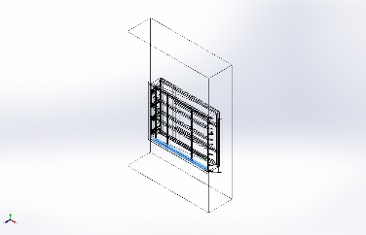 | Beam – Uniform C/S | Section Standard-  Section Area: 0.00131018m^2  Length:2,219.8mm  Volume:0.00290835m^3  Mass Density:7,870kg/m^3  Mass:22.8887kg  Weight:224.31N | E:\NIHVA AUTOMATION 2024\AUTOMATION\DOCK LEVELER\NEW DEVLOPMENT\DOCK PLATE-R01.SLDPRT  Apr 19 10:54:25 2025
SolidBody 14(Trim/Extend15[2])  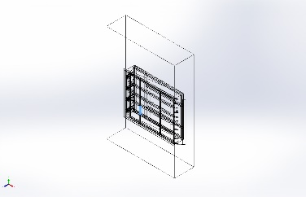 | Beam – Uniform C/S | Section Standard-weldment profiles/iso/rectangular tube  Section Area: 0.000720823m^2  Length:376.248mm  Volume:0.000272526m^3  Mass Density:7,870kg/m^3  Mass:2.14478kg  Weight:21.0188N | E:\NIHVA AUTOMATION 2024\AUTOMATION\DOCK LEVELER\NEW DEVLOPMENT\DOCK PLATE-R01.SLDPRT  Apr 19 10:54:25 2025
SolidBody 15(Trim/Extend13[1])  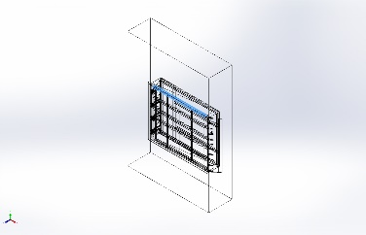 | Beam – Uniform C/S | Section Standard-weldment profiles/iso/c channel  Section Area: 0.00131018m^2  Length:2,219.8mm  Volume:0.00290835m^3  Mass Density:7,870kg/m^3  Mass:22.8887kg  Weight:224.31N | E:\NIHVA AUTOMATION 2024\AUTOMATION\DOCK LEVELER\NEW DEVLOPMENT\DOCK PLATE-R01.SLDPRT  Apr 19 10:54:25 2025
SolidBody 16(Trim/Extend15[8])  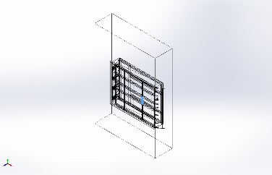 | Beam – Uniform C/S | Section Standard-weldment profiles/iso/rectangular tube  Section Area: 0.000720823m^2  Length:352.496mm  Volume:0.000256722m^3  Mass Density:7,870kg/m^3  Mass:2.02041kg  Weight:19.8N | E:\NIHVA AUTOMATION 2024\AUTOMATION\DOCK LEVELER\NEW DEVLOPMENT\DOCK PLATE-R01.SLDPRT  Apr 19 10:54:25 2025
SolidBody 17(Trim/Extend15[11])  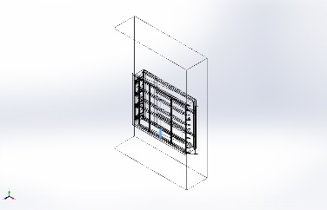 | Beam – Uniform C/S | Section Standard-weldment profiles/iso/rectangular tube  Section Area: 0.000720823m^2  Length:352.922mm  Volume:0.000254394m^3  Mass Density:7,870kg/m^3  Mass:2.00208kg  Weight:19.6204N | E:\NIHVA AUTOMATION 2024\AUTOMATION\DOCK LEVELER\NEW DEVLOPMENT\DOCK PLATE-R01.SLDPRT  Apr 19 10:54:25 2025
SolidBody 18(Trim/Extend10[4])  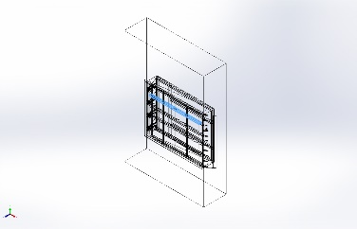 | Beam – Uniform C/S | Section Standard-weldment profiles/iso/c channel  Section Area: 0.00131018m^2  Length:2,183.83mm  Volume:0.00286764m^3  Mass Density:7,870kg/m^3  Mass:22.5683kg  Weight:221.169N | E:\NIHVA AUTOMATION 2024\AUTOMATION\DOCK LEVELER\NEW DEVLOPMENT\DOCK PLATE-R01.SLDPRT  Apr 19 10:54:25 2025
SolidBody 19(Trim/Extend15[5])  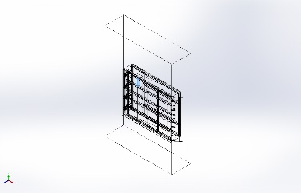 | Beam – Uniform C/S | Section Standard-weldment profiles/iso/rectangular tube  Section Area: 0.000720823m^2  Length:356.709mm  Volume:0.000257124m^3  Mass Density:7,870kg/m^3  Mass:2.02356kg  Weight:19.8309N | E:\NIHVA AUTOMATION 2024\AUTOMATION\DOCK LEVELER\NEW DEVLOPMENT\DOCK PLATE-R01.SLDPRT  Apr 19 10:54:25 2025
SolidBody 20(Trim/Extend10[2])  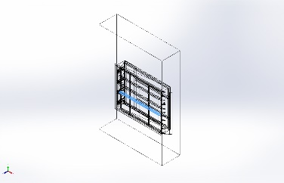 | Beam – Uniform C/S | Section Standard-weldment profiles/iso/c channel  Section Area: 0.00131018m^2  Length:2,183.83mm  Volume:0.00286764m^3  Mass Density:7,870kg/m^3  Mass:22.5683kg  Weight:221.169N | E:\NIHVA AUTOMATION 2024\AUTOMATION\DOCK LEVELER\NEW DEVLOPMENT\DOCK PLATE-R01.SLDPRT  Apr 19 10:54:25 2025
SolidBody 22(Trim/Extend15[6])  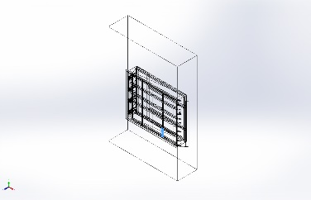 | Beam – Uniform C/S | Section Standard-weldment profiles/iso/rectangular tube  Section Area: 0.000720823m^2  Length:352.922mm  Volume:0.000254394m^3  Mass Density:7,870kg/m^3  Mass:2.00208kg  Weight:19.6204N | E:\NIHVA AUTOMATION 2024\AUTOMATION\DOCK LEVELER\NEW DEVLOPMENT\DOCK PLATE-R01.SLDPRT  Apr 19 10:54:25 2025
SolidBody 23(Trim/Extend15[12])  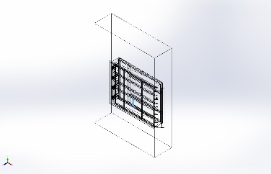 | Beam – Uniform C/S | Section Standard-weldment profiles/iso/rectangular tube  Section Area: 0.000720823m^2  Length:376.248mm  Volume:0.000272526m^3  Mass Density:7,870kg/m^3  Mass:2.14478kg  Weight:21.0188N | E:\NIHVA AUTOMATION 2024\AUTOMATION\DOCK LEVELER\NEW DEVLOPMENT\DOCK PLATE-R01.SLDPRT  Apr 19 10:54:25 2025
SolidBody 24(Trim/Extend15[4])  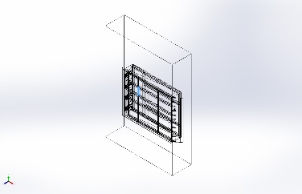 | Beam – Uniform C/S | Section Standard-weldment profiles/iso/rectangular tube  Section Area: 0.000720823m^2  Length:376.248mm  Volume:0.000272526m^3  Mass Density:7,870kg/m^3  Mass:2.14478kg  Weight:21.0188N | E:\NIHVA AUTOMATION 2024\AUTOMATION\DOCK LEVELER\NEW DEVLOPMENT\DOCK PLATE-R01.SLDPRT  Apr 19 10:54:25 2025
SolidBody 1(Angle iron - configured 35 X 35 X 5(1)[2])  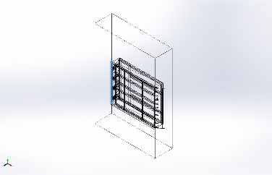 | Beam – Uniform C/S | Section Standard-weldment profiles/iso/angle iron  Section Area: 0.000719635m^2  Length:2,050.45mm  Volume:0.00147558m^3  Mass Density:7,870kg/m^3  Mass:11.6128kg  Weight:113.805N | E:\NIHVA AUTOMATION 2024\AUTOMATION\DOCK LEVELER\NEW DEVLOPMENT\PIT 3D DWG.SLDPRT  Apr 9 16:01:52 2025
SolidBody 2(Angle iron - configured 35 X 35 X 5(1)[3])  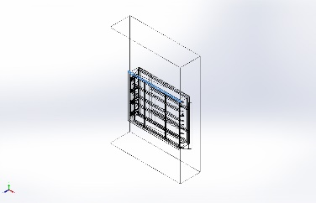 | Beam – Uniform C/S | Section Standard-weldment profiles/iso/angle iron  Section Area: 0.000719635m^2  Length:2,540.22mm  Volume:0.00182804m^3  Mass Density:7,870kg/m^3  Mass:14.3866kg  Weight:140.989N | E:\NIHVA AUTOMATION 2024\AUTOMATION\DOCK LEVELER\NEW DEVLOPMENT\PIT 3D DWG.SLDPRT  Apr 9 16:01:52 2025
SolidBody 3(Angle iron - configured 35 X 35 X 5(1)[1])  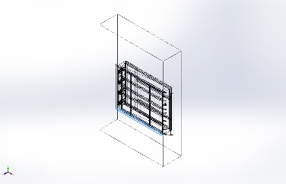 | Beam – Uniform C/S | Section Standard-weldment profiles/iso/angle iron  Section Area: 0.000719635m^2  Length:2,540.22mm  Volume:0.00182803m^3  Mass Density:7,870kg/m^3  Mass:14.3866kg  Weight:140.989N | E:\NIHVA AUTOMATION 2024\AUTOMATION\DOCK LEVELER\NEW DEVLOPMENT\PIT 3D DWG.SLDPRT  Apr 9 16:01:52 2025

Study Properties
Study name | Static 1
Analysis type | Static
Mesh type | Mixed Mesh
Thermal Effect: | On
Thermal option | Include temperature loads
Zero strain temperature | 298 Kelvin
Include fluid pressure effects from SOLIDWORKS Flow Simulation | Off
Solver type | Direct sparse solver
Inplane Effect: | Off
Soft Spring: | Off
Inertial Relief: | Off
Incompatible bonding options | Automatic
Large displacement | Off
Compute free body forces | On
Friction | Off
Use Adaptive Method: | Off
Result folder | SOLIDWORKS document (E:\NIHVA AUTOMATION 2024\AUTOMATION\DOCK LEVELER\NEW DEVLOPMENT)

Units
Unit system: | SI (MKS)
Length/Displacement | mm
Temperature | Kelvin
Angular velocity | Rad/sec
Pressure/Stress | N/m^2

Material Properties
Model Reference | Properties | Components
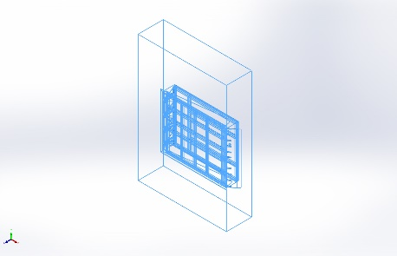 |  | SolidBody 1(Cut-Extrude4[1])(1600 mm filp plate-R01-1),  SolidBody 2(Cut-Extrude4[2])(1600 mm filp plate-R01-1),  SolidBody 3(Chamfer3)(1600 mm filp plate-R01-1),  SolidBody 1(Trim/Extend3[2])(BASE STRACTURE-1),  SolidBody 2(Trim/Extend2[2])(BASE STRACTURE-1),  SolidBody 3(Sb beam - configured 100 X 8(2)[1])(BASE STRACTURE-1),  SolidBody 4(C channel - configured 100 X 10(4)[3])(BASE STRACTURE-1),  SolidBody 5(C channel - configured 100 X 10(4)[7])(BASE STRACTURE-1),  SolidBody 6(C channel - configured 100 X 10(4)[6])(BASE STRACTURE-1),  SolidBody 7(Sb beam - configured 100 X 8(2)[2])(BASE STRACTURE-1),  SolidBody 8(Sb beam - configured 100 X 8(2)[4])(BASE STRACTURE-1),  SolidBody 9(Trim/Extend3[1])(BASE STRACTURE-1),  SolidBody 10(Trim/Extend1[2])(BASE STRACTURE-1),  SolidBody 11(Sb beam - configured 100 X 8(2)[3])(BASE STRACTURE-1),  SolidBody 12(C channel - configured 100 X 10(4)[5])(BASE STRACTURE-1),  SolidBody 1(Trim/Extend15[15])(DECK ASSEMBLY-R01-1/DOCK PLATE-R01-1),  SolidBody 2(Trim/Extend15[3])(DECK ASSEMBLY-R01-1/DOCK PLATE-R01-1),  SolidBody 3(Trim/Extend14[1])(DECK ASSEMBLY-R01-1/DOCK PLATE-R01-1),  SolidBody 4(Trim/Extend15[14])(DECK ASSEMBLY-R01-1/DOCK PLATE-R01-1),  SolidBody 5(Trim/Extend15[1])(DECK ASSEMBLY-R01-1/DOCK PLATE-R01-1),  SolidBody 6(Trim/Extend12[2])(DECK ASSEMBLY-R01-1/DOCK PLATE-R01-1),  SolidBody 7(Trim/Extend15[7])(DECK ASSEMBLY-R01-1/DOCK PLATE-R01-1),  SolidBody 8(Trim/Extend10[3])(DECK ASSEMBLY-R01-1/DOCK PLATE-R01-1),  SolidBody 9(Trim/Extend15[13])(DECK ASSEMBLY-R01-1/DOCK PLATE-R01-1),  SolidBody 10(Trim/Extend10[1])(DECK ASSEMBLY-R01-1/DOCK PLATE-R01-1),  SolidBody 11(Trim/Extend15[10])(DECK ASSEMBLY-R01-1/DOCK PLATE-R01-1),  SolidBody 12(Trim/Extend15[9])(DECK ASSEMBLY-R01-1/DOCK PLATE-R01-1),  SolidBody 13(Trim/Extend14[2])(DECK ASSEMBLY-R01-1/DOCK PLATE-R01-1),  SolidBody 14(Trim/Extend15[2])(DECK ASSEMBLY-R01-1/DOCK PLATE-R01-1),  SolidBody 15(Trim/Extend13[1])(DECK ASSEMBLY-R01-1/DOCK PLATE-R01-1),  SolidBody 16(Trim/Extend15[8])(DECK ASSEMBLY-R01-1/DOCK PLATE-R01-1),  SolidBody 17(Trim/Extend15[11])(DECK ASSEMBLY-R01-1/DOCK PLATE-R01-1),  SolidBody 18(Trim/Extend10[4])(DECK ASSEMBLY-R01-1/DOCK PLATE-R01-1),  SolidBody 19(Trim/Extend15[5])(DECK ASSEMBLY-R01-1/DOCK PLATE-R01-1),  SolidBody 20(Trim/Extend10[2])(DECK ASSEMBLY-R01-1/DOCK PLATE-R01-1),  SolidBody 21(Boss-Extrude4)(DECK ASSEMBLY-R01-1/DOCK PLATE-R01-1),  SolidBody 22(Trim/Extend15[6])(DECK ASSEMBLY-R01-1/DOCK PLATE-R01-1),  SolidBody 23(Trim/Extend15[12])(DECK ASSEMBLY-R01-1/DOCK PLATE-R01-1),  SolidBody 24(Trim/Extend15[4])(DECK ASSEMBLY-R01-1/DOCK PLATE-R01-1),  SolidBody 1(Boss-Extrude1)(DECK ASSEMBLY-R01-1/Dack flip plate bkt new-1),  SolidBody 1(Boss-Extrude1)(DECK ASSEMBLY-R01-1/Dack flip plate bkt new-2),  SolidBody 1(Boss-Extrude1)(DECK ASSEMBLY-R01-1/Dack flip plate bkt new-3),  SolidBody 1(Boss-Extrude1)(DECK ASSEMBLY-R01-1/Dack flip plate bkt new-4),  SolidBody 1(Boss-Extrude1)(DECK ASSEMBLY-R01-1/Dack flip plate bkt new-5),  SolidBody 1(Boss-Extrude1)(DECK ASSEMBLY-R01-1/Dack flip plate bkt new-6),  SolidBody 1(Cut-Extrude4)(DECK ASSEMBLY-R01-1/MS dia 25 Rod-R011-1),  SolidBody 1(Cut-Extrude2)(Dack bar new-1),  SolidBody 1(Cut-Extrude2)(Dack bar new-2),  SolidBody 1(Boss-Extrude1)(FOR SUPPORT-1),  SolidBody 1(Boss-Extrude1)(FOR SUPPORT-2),  SolidBody 1(Boss-Extrude1)(FOR SUPPORT-4),  SolidBody 1(Boss-Extrude1)(FOR SUPPORT-6),  SolidBody 1(Fillet1)(Flip Plate MTG BKT R01-1),  SolidBody 1(Fillet1)(Flip Plate MTG BKT R01-10),  SolidBody 1(Fillet1)(Flip Plate MTG BKT R01-11),  SolidBody 1(Fillet1)(Flip Plate MTG BKT R01-2),  SolidBody 1(Fillet1)(Flip Plate MTG BKT R01-3),  SolidBody 1(Fillet1)(Flip Plate MTG BKT R01-4),  SolidBody 1(Fillet1)(Flip Plate MTG BKT R01-5),  SolidBody 1(Fillet1)(Flip Plate MTG BKT R01-6),  SolidBody 1(Fillet1)(Flip Plate MTG BKT R01-7),  SolidBody 1(Fillet1)(Flip Plate MTG BKT R01-8),  SolidBody 1(Fillet1)(Flip Plate MTG BKT R01-9),  SolidBody 1(Boss-Extrude1)(MTG Block new 17-03-15),  SolidBody 1(Boss-Extrude1)(MTG Block new 17-03-4),  SolidBody 1(Boss-Extrude1)(MTG Block new 17-03-6),  SolidBody 1(Boss-Extrude1)(MTG Block new 17-03-9),  SolidBody 1(Angle iron - configured 35 X 35 X 5(1)[2])(PIT 3D DWG-1),  SolidBody 2(Angle iron - configured 35 X 35 X 5(1)[3])(PIT 3D DWG-1),  SolidBody 3(Angle iron - configured 35 X 35 X 5(1)[1])(PIT 3D DWG-1),  SolidBody 4(Cut-Extrude1)(PIT 3D DWG-1),  SolidBody 1(Boss-Extrude1)(RIB R01-1),  SolidBody 1(Boss-Extrude1)(RIB R01-11),  SolidBody 1(Boss-Extrude1)(RIB R01-13),  SolidBody 1(Boss-Extrude1)(RIB R01-15),  SolidBody 1(Boss-Extrude1)(RIB R01-3),  SolidBody 1(Boss-Extrude1)(RIB R01-5),  SolidBody 1(Boss-Extrude1)(RIB R01-7),  SolidBody 1(Boss-Extrude1)(RIB R01-9),  SolidBody 1(Boss-Extrude1)(Side Cover R01-1),  SolidBody 1(Boss-Extrude1)(Side Cover R01-2),  SolidBody 1(Boss-Extrude1)(dack bkt new-R01-1),  SolidBody 1(Boss-Extrude1)(dack bkt new-R01-2),  SolidBody 1(Boss-Extrude1)(dack bkt new-R01-3),  SolidBody 1(Boss-Extrude1)(dack bkt new-R01-4),  SolidBody 1(Boss-Extrude1)(dack bkt new-R01-5),  SolidBody 1(Boss-Extrude1)(dack bkt new-R01-6),  SolidBody 1(Boss-Extrude1)(dack bkt new-R01-7),  SolidBody 1(Boss-Extrude1)(dack bkt new-R01-8)
  Name: | AISI 1020 Steel, Cold Rolled
  Model type: | Linear Elastic Isotropic
  Default failure criterion: | Max von Mises Stress
  Yield strength: | 3.5e+08 N/m^2
  Tensile strength: | 4.2e+08 N/m^2
  Elastic modulus: | 2.05e+11 N/m^2
  Poisson's ratio: | 0.29
  Mass density: | 7,870 kg/m^3
  Shear modulus: | 8e+10 N/m^2
  Thermal expansion coefficient: | 1.17e-05 /Kelvin
Curve Data:N/A

Loads and Fixtures
Fixture name | Fixture Image | Fixture Details
Fixed-1 | 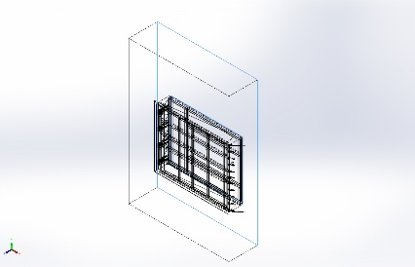
  Entities: | 2 face(s)
  Type: | Fixed Geometry

Load name | Load Image | Load Details
Force-1 | 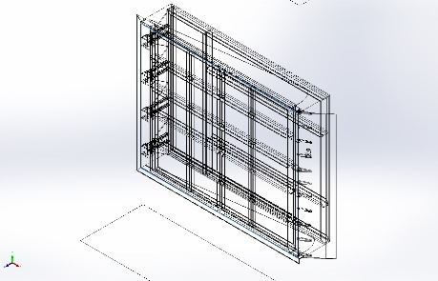
  Entities: | 1 face(s)
  Type: | Apply normal force
  Value: | 1 N

Connector Definitions
No Data

Contact Information

Contact | Contact Image | Contact Properties
Global Contact | 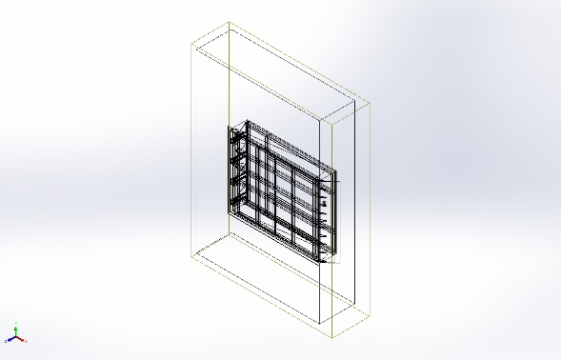
  Type: | Bonded
  Components: | 1 component(s)
  Options: | Incompatible mesh

Mesh information
Mesh type | Mixed Mesh
Mesher Used: | Curvature-based mesh
Jacobian points for High quality mesh | 16 Points
Jacobian check for shell | Off
Maximum element size | 247.063 mm
Minimum element size | 12.3531 mm
Mesh Quality | High

Sensor Details
No Data

Resultant Forces
No Data
No Data

Beams
No Data

Study Results
No Data

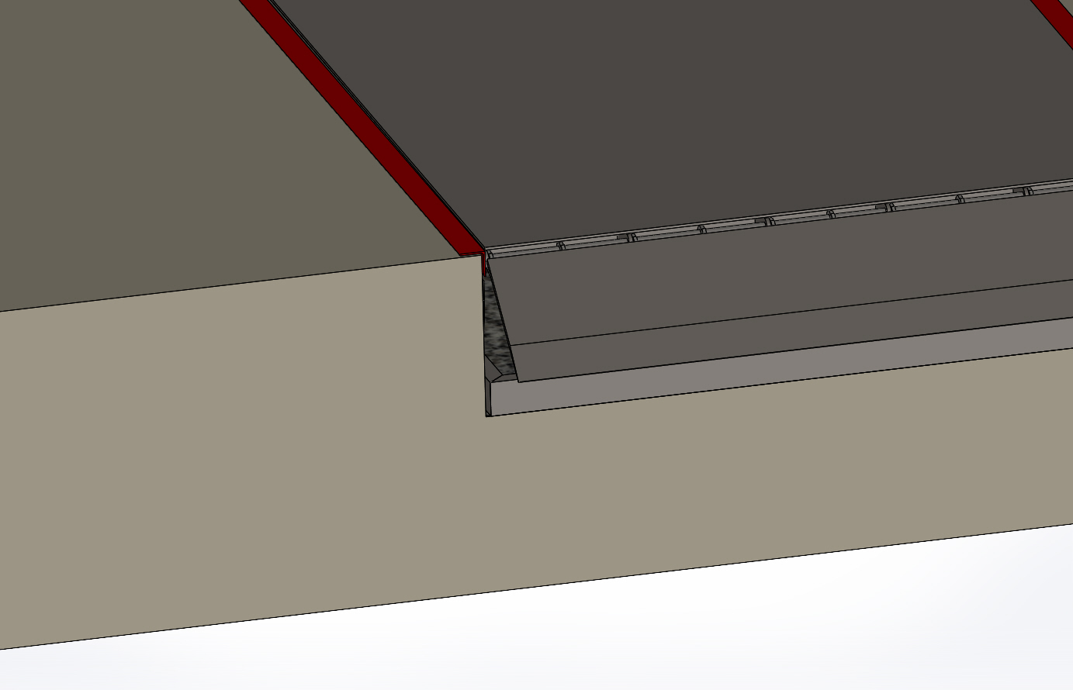
Image-1

Conclusion

